Algorithm and AI Relevance
Bimodal Audio–Visual Fusion with Spatial–Temporal Network Analysis for Early Detection of Red Palm Weevil Infestation
Supplementary technical note — algorithm formulation, mathematical steps, and AI-perspective analysis
This note isolates and formalises the core algorithm of the proposed system described in the project report (“AI-Enabled Audio–Visual Fusion with Spatial-Temporal Network Analysis for Early Detection of Red Palm Weevil Infestation in Coconut Trees”). It is organised in two parts: Part A walks through the algorithm's mathematical steps stage by stage, and Part B analyses the algorithm from an AI/ML perspective and presents a modified, formally stated version of it (Algorithm 2) that folds in the improvements identified in that analysis.

Part A — Mathematical Steps in the Algorithm
The proposed pipeline extends two design patterns found in the base papers reviewed for this project: the audio–visual fuzzy-fusion pipeline of RED-BIYO (Siron Anita Susan T. et al.) and the lightweight spectrogram-classifier pipeline of the acoustic FFNN paper (Abinaya S. et al.), together with a Nano-scale YOLO visual detector. It adds a spatial–temporal network-analysis layer that neither base paper has. Figure A.1 gives the full flow; the steps below walk through each block's mathematics.

A.1 Flowchart
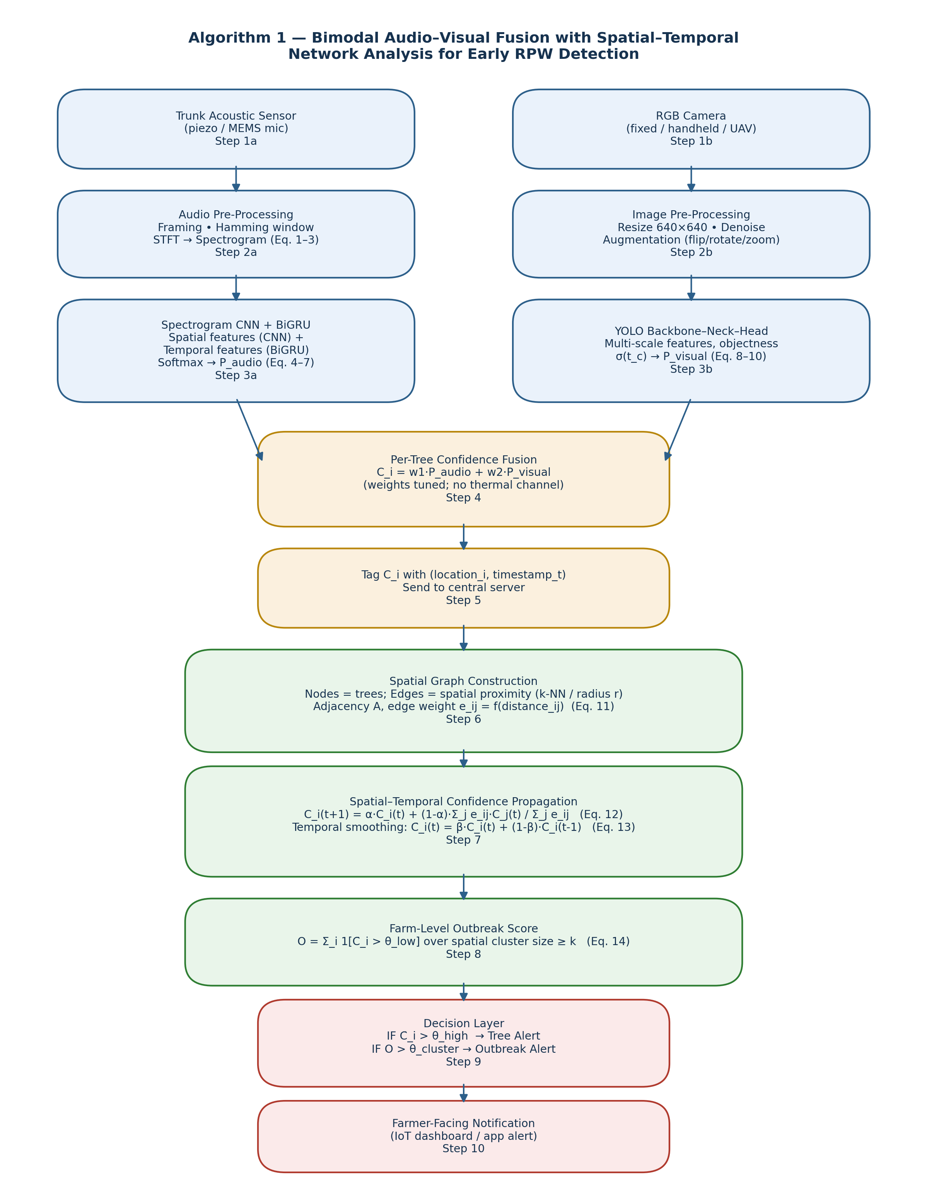
Figure A.1 — Algorithm 1: end-to-end flow from dual-sensor acquisition to farm-level alert.

A.2 Step-by-step mathematical walkthrough

Step 1 — Dual-sensor data acquisition
Each monitored tree i produces two raw streams at time t: an acoustic signal x_i(n) captured by a trunk-mounted piezo/MEMS microphone, and an RGB image I_i captured by a fixed, handheld, or UAV-mounted camera. No thermal channel is captured (dropped from the original three-modality plan on feasibility grounds).

Step 2a — Audio pre-processing (framing, windowing, STFT)
The raw signal is split into overlapping frames and multiplied by a Hamming window to reduce spectral leakage:
x_w(n) = x(n)·w(n), 0 ≤ n ≤ N-1
w(n) = 0.54 − 0.46·cos(2πn / (N−1)) ...(Eq. 1)
A 512-point Short-Time Fourier Transform converts each windowed frame into a time–frequency representation, and the magnitude is taken to form the spectrogram:
STFT(m,k) = Σ_{n=0}^{N-1} x_w(n)·e^{-j2πkn/N}
S(m,k) = |STFT(m,k)| ...(Eq. 2)
Min–max normalisation maps the spectrogram to [0,1] so that amplitude differences across recordings do not bias the classifier:
S_norm(m,k) = (S(m,k) − S_min) / (S_max − S_min) ...(Eq. 3)

Step 3a — Audio classification: spatial + temporal feature learning → P_audio
A convolutional front end extracts spatial–frequency patterns from S_norm, and a recurrent layer (Bidirectional GRU, following the CNN-BiGRU pattern used for rice-disease and RPW acoustic classification in the surveyed literature) captures how those patterns evolve across frames. At each recurrent step r the BiGRU computes reset gate b_r, update gate d_r, candidate state, and final hidden state:
b_r = σ(Z_b p_r + J_b q_{r-1} + f_b)
d_r = σ(Z_d p_r + J_d q_{r-1} + f_d)
q̃_r = tanh(Z_q p_r + J_q (q_{r-1}⊗b_r) + f_r)
q_r = (1-d_r)⊗q_{r-1} + d_r⊗q̃_r ...(Eq. 4–7)
Forward and backward hidden states are concatenated (Q_r = forward ⊕ backward) and passed through a fully connected layer with a sigmoid output, giving the audio-branch infestation probability P_audio ∈ [0,1]. For the lightweight edge-deployment variant, the CNN-BiGRU is replaceable by the simpler feed-forward network (512→256→128→1 neurons, ReLU/sigmoid) validated in the acoustic base paper on MFCC + spectral-contrast features, trading a small amount of accuracy for real-time inference on constrained hardware.

Step 2b — Image pre-processing
Each RGB frame is resized to 640×640, and — during training only — augmented with random horizontal flip (p=0.5), rotation in [−20°, +20°], and zoom up to 25%, to introduce geometric variability while preserving semantic structure.

Step 3b — Visual detection: YOLO backbone–neck–head → P_visual
The backbone extracts hierarchical features through convolution + batch-norm + SiLU blocks:
Conv(I,N,c,b) = SiLU(BatchNorm(I,℘)) ...(Eq. 8)
The neck (FPN + PAN) fuses multi-scale feature maps top-down and bottom-up so that both small (early borehole) and large (visible damage) targets are represented:
P_l = UpSample(C_{l+1}) + C_l
U_l = Conv(Concat(P_{l-1}, DownSample(P_l))) ...(Eq. 9)
The head regresses bounding boxes and an objectness score, passed through a sigmoid so it lies in [0,1]; the maximum objectness score among detected regions for tree i is taken as the visual-branch infestation probability P_visual:
o = σ(t_c); P_visual = max_k o_k ...(Eq. 10)
Training minimises a composite loss over localisation, objectness, and classification terms, l = λ_loc·l_loc + λ_obj·l_obj + λ_cls·l_cls, exactly as in the YOLOv9/YOLOv11-Nano base papers.

Step 4 — Per-tree confidence fusion
P_audio and P_visual are combined into a single per-tree confidence score C_i. Two equivalent formulations are used in the literature and are both compatible with this pipeline: a Mamdani fuzzy-rule fusion (as in RED-BIYO, where each probability is fuzzified into Low/Medium/High Gaussian membership terms and IF–THEN rules such as “IF audio is High AND visual is High THEN Not Healthy” are aggregated and defuzzified), or the lighter confidence-weighted linear fusion adopted as the default in this project for edge deployment:
C_i = w1·P_audio + w2·P_visual, w1+w2 = 1 ...(Eq. 11)
w1, w2 are tuned on a validation split (or replaced by the fuzzy rule base when compute budget allows), reflecting that acoustic and visual evidence are not always equally reliable — e.g. wind noise degrades P_audio, while occlusion or poor lighting degrades P_visual.

Step 5 — Geotagging and central aggregation
Each fused score C_i is tagged with the tree's location (from GPS/fixed installation ID) and the scan timestamp t, and transmitted to a central server. This is the step that is entirely absent from the single-tree base papers and is the entry point into the network-analysis layer.

Step 6 — Spatial graph construction
The plantation is modelled as a graph G = (V, E) where each tree is a node v_i ∈ V. Edges connect spatially proximate trees, either by k-nearest-neighbours or by a fixed radius r, with an edge weight that decays with physical distance (a Gaussian/RBF kernel is a natural default since RPW spread probability falls off with distance):
e_ij = exp( − d(i,j)² / (2σ²) ) if d(i,j) ≤ r, else 0 ...(Eq. 12)

Step 7 — Spatial–temporal confidence propagation
This is the key mathematical novelty of the algorithm. Confidence is smoothed across the graph so that a tree with rising but individually sub-threshold confidence, surrounded by neighbours that are also rising, gets pulled toward alert status faster than an isolated rising score would — mirroring how RPW infestation actually spreads palm to palm. The spatial update is a one-hop diffusion (graph Laplacian smoothing):
C_i(t+1) = α·C_i(t) + (1−α)· [Σ_j e_ij·C_j(t)] / [Σ_j e_ij] ...(Eq. 13)
and a temporal update applies exponential smoothing across successive scans so that a single noisy reading cannot trigger an alert on its own:
C̄_i(t) = β·C_i(t) + (1−β)·C̄_i(t−1) ...(Eq. 14)
α ∈ [0,1] controls how much weight is given to a tree's own reading versus its neighbours (α → 1 recovers the pure per-tree base-paper behaviour); β ∈ [0,1] controls how much weight is given to the newest scan versus accumulated history.

Step 8 — Farm-level outbreak scoring
A cluster-aware outbreak score counts spatially contiguous trees whose smoothed confidence exceeds a low watch-threshold θ_low, only counting a cluster if it has at least k members — this is what lets the system flag an emerging outbreak before any single tree crosses the hard alert threshold:
O = Σ_i 1[C̄_i(t) > θ_low] over connected clusters of size ≥ k ...(Eq. 15)

Step 9 — Decision layer
Two independent alert conditions are checked at every scan:
IF C̄_i(t) > θ_high → Tree-level alert for tree i
IF O(t) > θ_cluster → Farm-level outbreak alert ...(Eq. 16)

Step 10 — Farmer-facing notification
Alerts are pushed to an IoT dashboard / mobile app (in the spirit of the Blynk-based notifier used in RED-BIYO), carrying the tree ID(s), location, confidence trend, and, for outbreak alerts, the flagged cluster boundary.

Part B — AI Perspective and the Modified Algorithm

B.1 What each stage represents from an AI standpoint
Read as a whole, Algorithm 1 chains together four distinct families of AI technique, each chosen for what it is good at:
- Representation learning (Steps 2–3): STFT + CNN/BiGRU and the YOLO backbone/neck are both learned feature extractors — the network discovers which spectro-temporal or spatial patterns correlate with infestation rather than relying on hand-crafted rules, which is exactly what makes early, weakly-visible/weakly-audible symptoms detectable at all.
- Supervised discriminative modelling (Steps 3a/3b outputs): both branches end in a probability estimate trained against expert-labelled data (infested/non-infested audio clips; boreholes/damage bounding boxes) — this is standard supervised deep learning, and it is why the accuracy figures reported in the literature (audio-only ≈85–99%, YOLO-visual ≈92–99%) are meaningful benchmarks for each branch on its own.
- Decision-level multimodal fusion (Step 4): whether implemented as a fuzzy inference system (Mamdani rules + centroid defuzzification, as in RED-BIYO) or as learned linear weights, this is the AI-relevant step that compensates for each sensor's failure mode — audio is weather-sensitive, vision is occlusion/lighting-sensitive — by letting the more reliable modality dominate the fused decision.
- Graph-based relational inference (Steps 6–8): this is the part with no precedent in the surveyed literature. Equation 13 is a one-hop message-passing / label-propagation update — structurally the same operation a Graph Neural Network's spatial-convolution layer performs (aggregate neighbour features, mix with the node's own state). Framing plantation-wide monitoring this way is what turns a set of independent per-tree classifiers into a system that reasons about spread, which is the actual epidemiological behaviour of RPW.

B.2 Where the base-paper algorithms stop, and what changes
Aspect | RED-BIYO / acoustic-FFNN base papers | Proposed modified algorithm
Sensing modalities | Audio + stem image (RED-BIYO also assumed a coconut-microphone + camera pair; the standalone acoustic paper is audio-only) | Audio + RGB image; thermal channel explicitly dropped for feasibility
Fusion mechanism | Mamdani fuzzy IF–THEN rules, hand-set Gaussian membership functions | Confidence-weighted linear fusion (Eq. 11) by default, with the fuzzy rule base retained as a drop-in alternative when compute allows
Unit of decision | One tree, one scan, in isolation | One tree per scan, plus a farm-level cluster score aggregated over the plantation graph
Temporal handling | None — each scan is evaluated independently | Exponential smoothing across scans (Eq. 14) so a single noisy reading cannot trigger an alert alone
Spatial handling | None | Explicit spatial graph over trees with proximity-weighted propagation (Eq. 12–13)
Alert output | Per-tree Healthy / Not-Healthy | Per-tree alert AND a separate, earlier-firing farm-level outbreak alert (Eq. 15–16)
Target hardware | Workstation / GPU-class training and inference | Edge-first: Nano-scale YOLO + lightweight FFNN/CNN-BiGRU sized for Raspberry-Pi-class field or drone hardware
Table B.1 — Delta between the base-paper algorithms and the proposed modified algorithm.

B.3 Modified Algorithm (Algorithm 2, formal statement)
Input: streams {x_i(n), I_i} for trees i = 1..M; tree locations {loc_i}; thresholds θ_low, θ_high, θ_cluster; smoothing constants α, β; minimum cluster size k.
Output: per-tree alert set A_tree ⊆ {1..M}; farm-level outbreak flag with implicated cluster.
- For each tree i, pre-process the audio stream (Hamming window → STFT → magnitude → min–max normalise) to obtain S_norm,i.
- Pass S_norm,i through the CNN(+BiGRU) audio classifier to obtain P_audio,i ∈ [0,1].
- Pre-process the paired image I_i (resize, denoise) and run the YOLO detector to obtain P_visual,i = max objectness score over detections.
- Fuse: C_i(t) = w1·P_audio,i + w2·P_visual,i.
- Tag C_i(t) with (loc_i, t) and push to the central aggregator.
- (Re)build / update the spatial graph G = (V,E) with edge weights e_ij = exp(−d(i,j)²/2σ²) for d(i,j) ≤ r.
- Propagate spatially: C_i(t) ← α·C_i(t) + (1−α)·Σ_j e_ij C_j(t) / Σ_j e_ij.
- Smooth temporally: C̄_i(t) = β·C_i(t) + (1−β)·C̄_i(t−1).
- If C̄_i(t) > θ_high, add i to A_tree and raise a tree-level alert.
- Find connected clusters of nodes with C̄_i(t) > θ_low; for any cluster of size ≥ k, compute O and raise a farm-level outbreak alert if O > θ_cluster.
- Push all raised alerts, with location and confidence trend, to the farmer-facing IoT dashboard; return to Step 1 at the next scan interval.

B.4 Why this is a meaningful modification, not just an addition
The change is not merely appending a graph on top of an unchanged detector. Because Steps 7–9 feed back into the alert decision (Step 9/10) rather than only reporting a metric, the modified algorithm changes what counts as a positive: a tree can now be flagged sooner than its own hard threshold would allow, purely because its neighbours are also trending upward — which is the specific failure mode (late, isolated, per-tree-only alerts) identified in the literature survey. Equally, temporal smoothing (Eq. 14) makes the system more conservative against single noisy scans than either base paper, which only ever evaluated one scan at a time.

B.5 Limitations carried into the modified algorithm
- The linear fusion weights w1, w2 and the propagation constants α, β are hyperparameters that need field calibration; poorly chosen values can either over-smooth genuine isolated infestations or under-smooth noisy sensors.
- Graph construction assumes tree geolocation is available and reasonably accurate (GPS or fixed-plot mapping); dense plantations with GPS multipath error will need a fallback (e.g. planting-grid index instead of raw coordinates).
- The propagation step (Eq. 13) is a simple one-hop diffusion for interpretability and edge-compute cost; a learned graph neural network layer (trained end-to-end on labelled outbreak-spread data, once such a dataset exists) is the natural next step but requires temporally-labelled, spatially-registered outbreak data that does not yet exist in the public literature surveyed.

